4. ReactJS-HOL

1: Successful Creation of the Blog Application 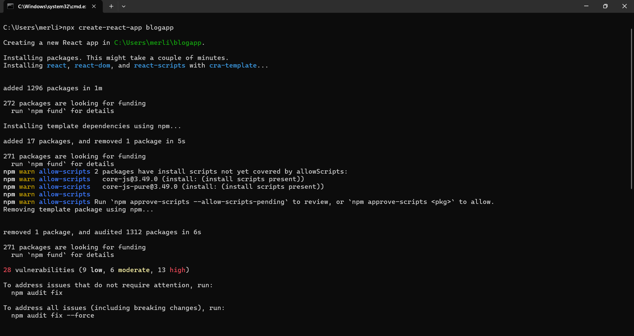
2: Opening the Blog Application in Visual Studio Code 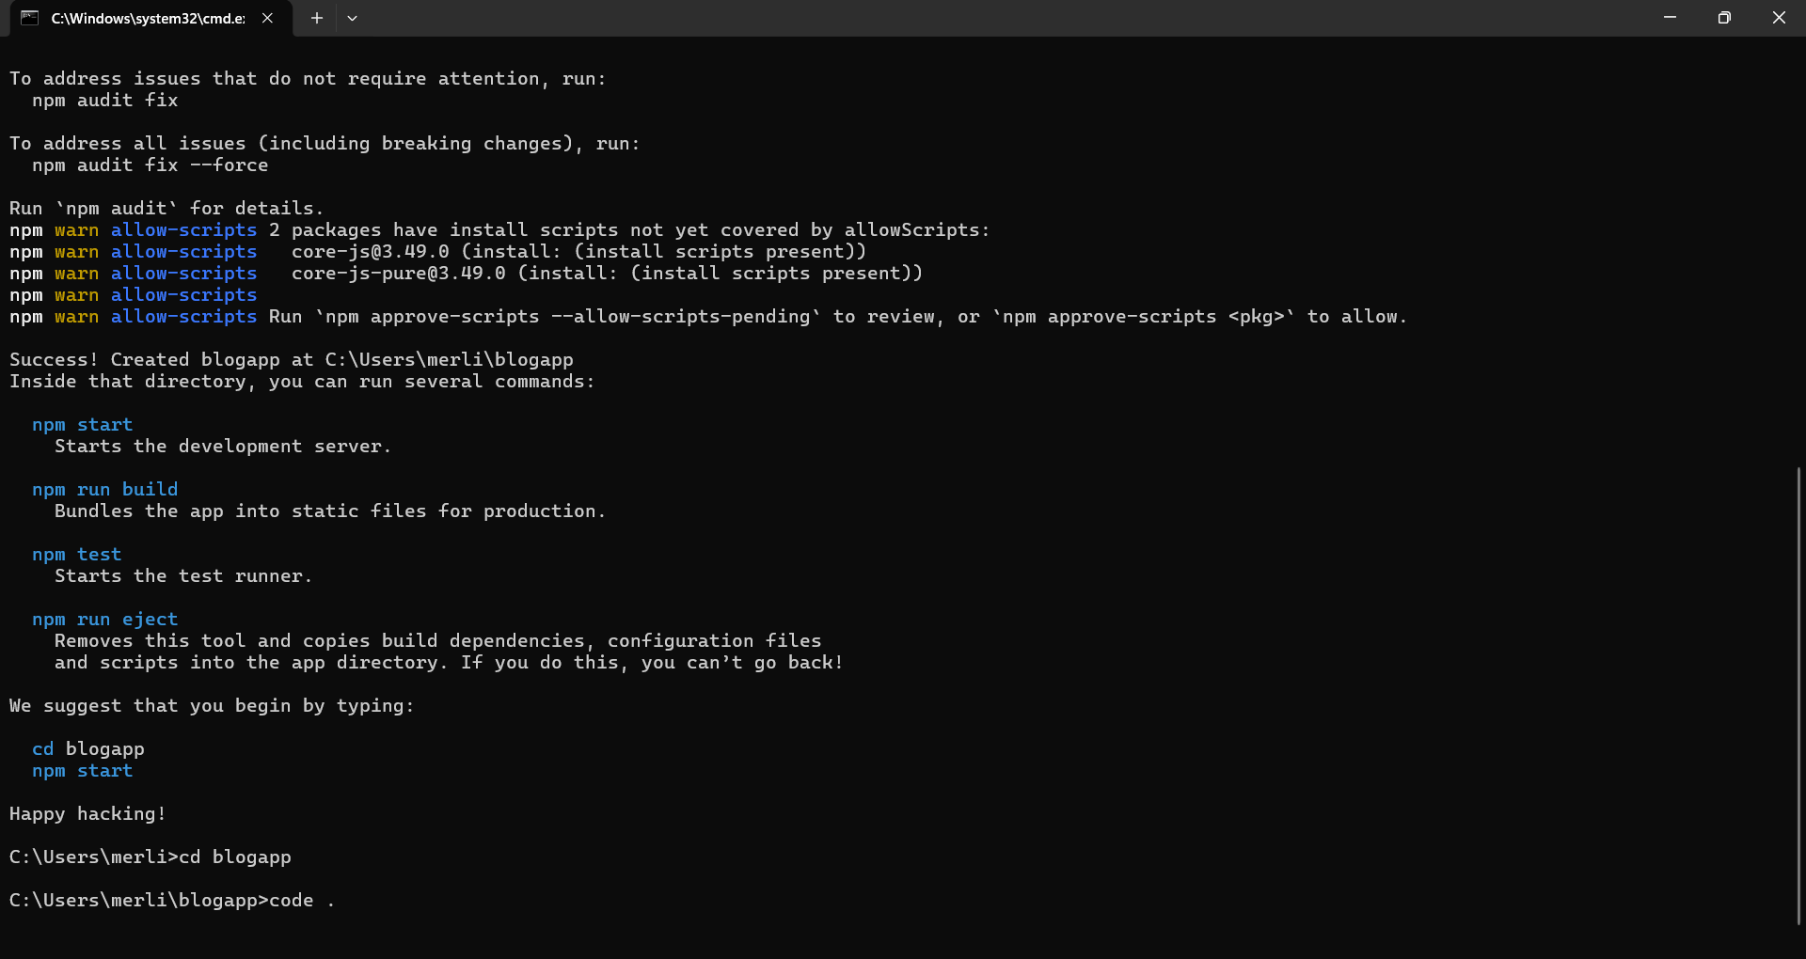

3: Successful Compilation and Execution of the Blog Application
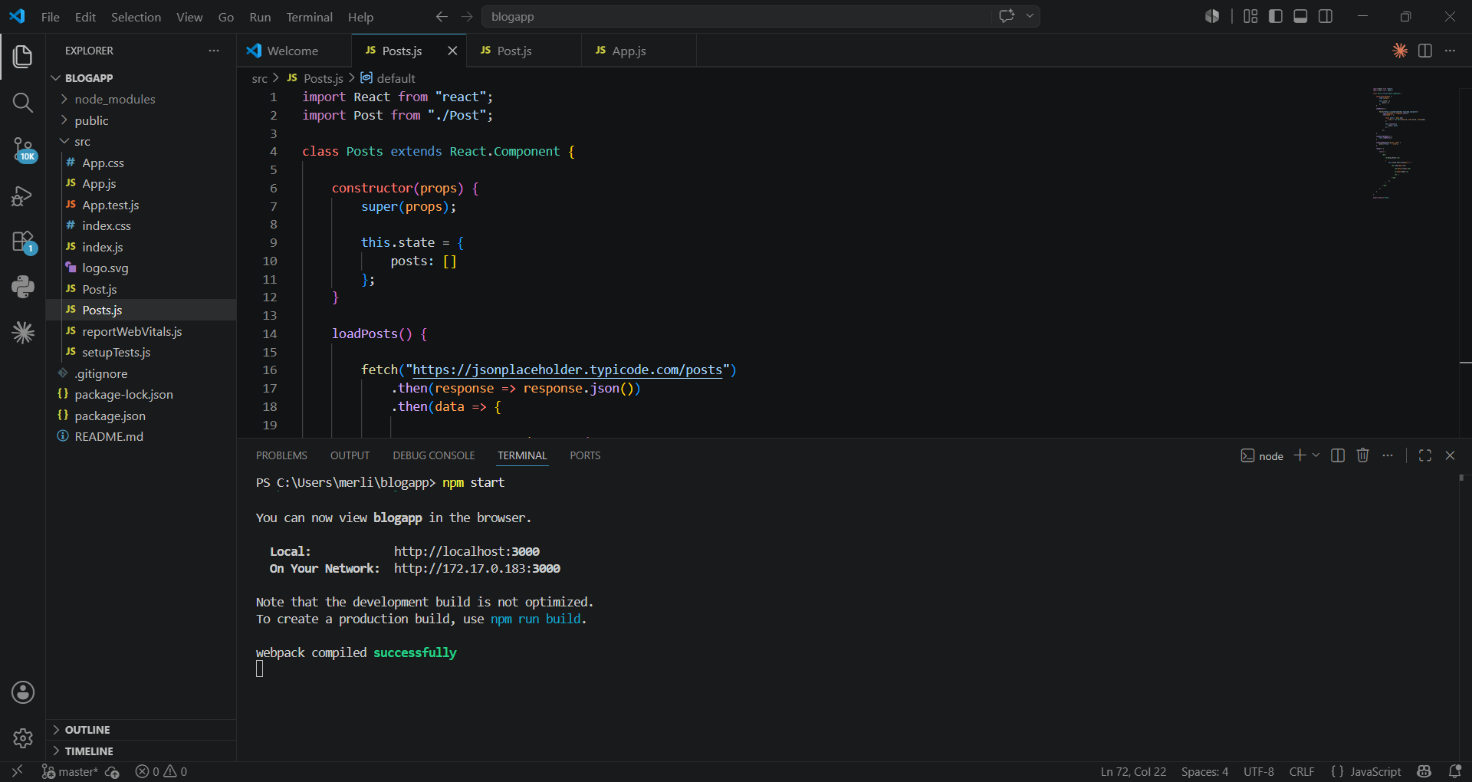4: Output of the Blog Posts Application 